## Exercise 5.1: Update Currency Rates from the Web (Currency Converter)

Extend your currency converter and let it update its currency rates directly from the *European Central Bank* (ECB).

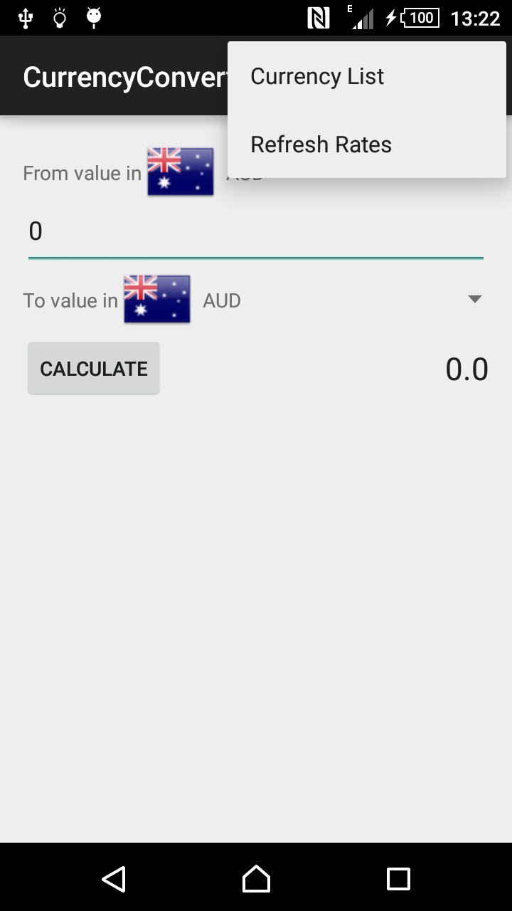

Steps:

* Add ExchangeRateDatabase with a method setExchangeRate.
* Add a menu entry *“Refresh Rates“*.

Create a method updateCurrencies() as part of your activity or in a separate class that is called when menu entry is selected:

* Load daily updated currency rates as XML from   
  <https://www.ecb.europa.eu/stats/eurofxref/eurofxref-daily.xml>
* Iterate through the data with a XML parser and upade the currency rates of your ExchangeRateDatabase

Remarks:

* Take care of the required permissions for your app.
* Use the trick from the lecture to be able to access the network from the UI thread. When running on a real device: Do you notice a lag?
* If the data in a ListView / Spinner does not refresh after updating the data you can force the UI to update the view with either calling invalidate() on the ListView or notifyDataSetChanged() on the Adapter.